SIMULATION EXPERIMENT – 9
9. Uniform Quantization and Finite Word-Length Effects in Digital Signal Processing Using MATLAB
Objectives of this Experiment:
1. To implement uniform quantization of a discrete-time signal using different word lengths.
2. To analyze quantization error produced by rounding and truncation.
3. To calculate SQNR and study the effect of word length on quantization performance.
4. To compare input/output quantization results and interpret finite word-length effects.
PROGRAM CODE:
clc; clear; close all;

%% FIR FILTER PARAMETERS
b = [0.0625 0.2500 0.3750 0.2500 0.0625];
Fs = 1000;
N = 128;

x = [1 zeros(1,N-1)];
n = 0:N-1;

%% 1. DIRECT REALIZATION
yd = filter(b,1,x);

%% 2. CASCADE REALIZATION
z = roots(b);
g = b(1);
yc = g*x;

for k = 1:length(z)
yc = filter([1 -z(k)],1,yc);
end
yc = real(yc);

%% 3. SYMMETRY AND LINEAR PHASE
symErr = max(abs(b-fliplr(b)));
D = (length(b)-1)/2;

if symErr < 1e-12
symmetry = 'Symmetric';
else
symmetry = 'Not Symmetric';
end

%% 4. FREQUENCY, PHASE AND GROUP DELAY
[H,w] = freqz(b,1,1024);
phase = unwrap(angle(H));
gd = grpdelay(b,1,1024);

%% 5. NUMERICAL COMPARISON
err = max(abs(yd-yc));
dev = err/max(abs(yd))*100;

%% =========================================================
% DISPLAY RESULTS
% =========================================================
fprintf('\n============================================\n');
fprintf(' FIR FILTER REALIZATION RESULTS\n');
fprintf('============================================\n');

fprintf('\nFIR Coefficients:\n');
disp(b);

fprintf('Sampling Frequency = %d Hz\n',Fs);
fprintf('Number of Samples = %d\n',N);

fprintf('Coefficient Symmetry = %s\n',symmetry);
fprintf('Symmetry Error = %.3e\n',symErr);
fprintf('Group Delay = %.2f samples\n',D);

fprintf('\nMaximum Error = %.3e\n',err);
fprintf('Percentage Deviation = %.3e %%\n',dev);

%% OUTPUT PARAMETER TABLE
Parameter = {
'Direct realization output'
'Cascade realization output'
'Impulse response'
'Phase response'
'Comparison of realizations'
};

Observation = {
'Direct FIR filtering'
'Cascade of first-order sections'
'Equal to FIR coefficient sequence'
'Linear phase'
'Equivalent transfer-function behavior'
};

Value = {
sprintf('[%.4f %.4f %.4f %.4f %.4f]',yd(1:5))
sprintf('[%.4f %.4f %.4f %.4f %.4f]',yc(1:5))
sprintf('[%.4f %.4f %.4f %.4f %.4f]',yd(1:5))
sprintf('Group delay = %.2f samples',D)
sprintf('Max error = %.3e; Deviation = %.3e %%',err,dev)
};

Unit_Note = {
'Amplitude'
'Amplitude'
'h[n]'
'Samples'
'Numerical precision'
};

Output_Table = table(Parameter,Observation,Value,Unit_Note);
fprintf('\n============================================\n');
fprintf('OUTPUT PARAMETER TABLE\n');
fprintf('============================================\n');
disp(Output_Table);

%% PLOTTING
figure('Name', 'Direct vs Cascade Impulse Response');
stem(n,yd,'filled'); hold on;
stem(n,yc,'--');
grid on; xlabel('Sample n'); ylabel('Amplitude');
title('Direct and Cascade FIR Impulse Responses');
legend('Direct Realization','Cascade Realization');

figure('Name', 'FIR Frequency and Phase Response');
subplot(2,1,1);
plot(w/pi,abs(H),'LineWidth',1.5); grid on;
xlabel('Normalized Frequency (\times\pi rad/sample)'); ylabel('|H(e^{j\omega})|');
title('FIR Magnitude Response');

subplot(2,1,2);
plot(w/pi,phase,'LineWidth',1.5); grid on;
xlabel('Normalized Frequency (\times\pi rad/sample)'); ylabel('Phase (radians)');
title('Unwrapped Phase Response');

figure('Name', 'Group Delay');
plot(w/pi,gd,'LineWidth',1.5); grid on;
xlabel('Normalized Frequency (\times\pi rad/sample)'); ylabel('Group Delay (samples)');
title('Group Delay');

figure('Name', 'Numerical Error');
plot(n,abs(yd-yc),'LineWidth',1.5); grid on;
xlabel('Sample n'); ylabel('Absolute Error');
title('Direct vs Cascade Numerical Error');
OUTPUT:
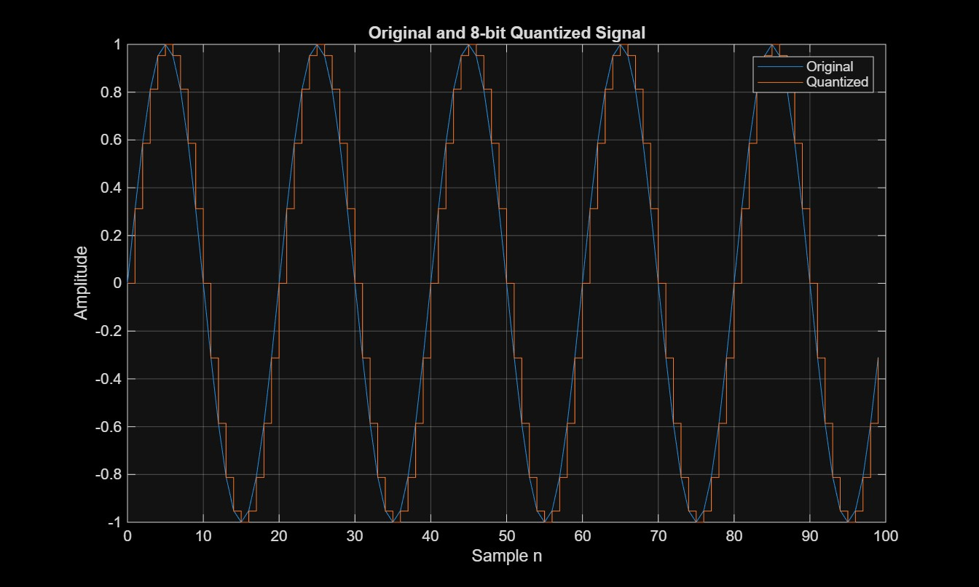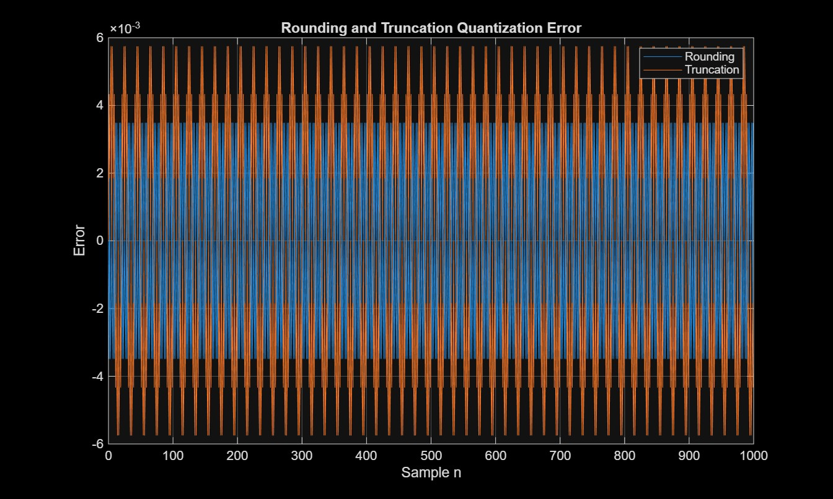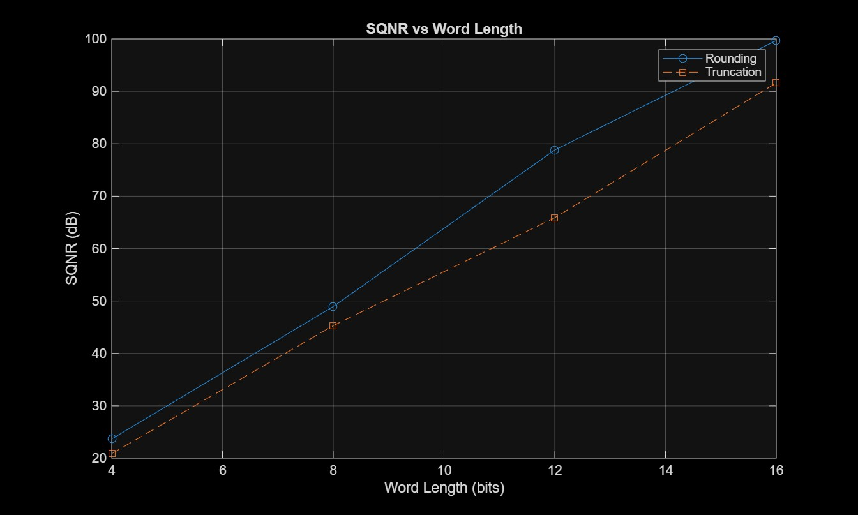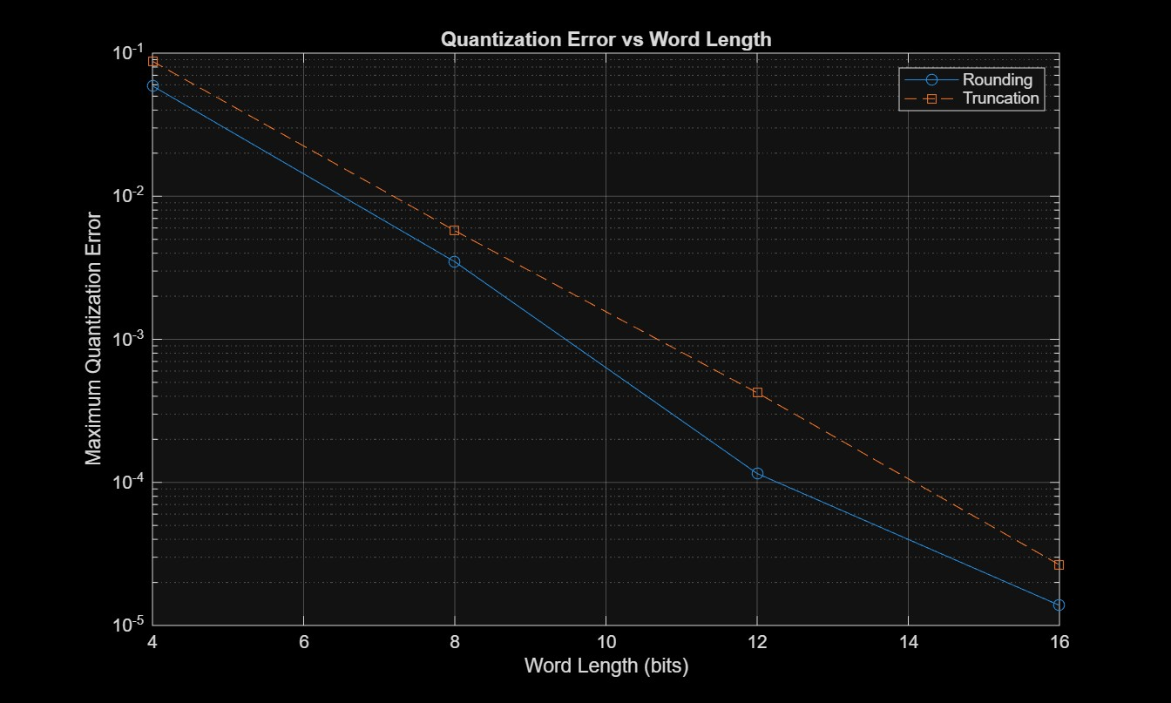
RESULT:

========== QUANTIZATION RESULTS ==========
Amplitude = 1.0 | Frequency = 50 Hz | Fs = 1000 Hz
Samples = 1000 | Main word length = 8 bits
8-bit Step Size = 0.0078125
Rounding SQNR = 48.9339 dB
Truncation SQNR = 45.2931 dB
Output SQNR = 48.9339 dB
Max Rounding Error = 0.003483
Max Truncation Error = 0.005744
Bits StepSize SQNR_Round_dB SQNR_Trunc_dB MaxError_Round MaxError_Trunc
____ __________ _____________ _____________ ______________ ______________

4 0.125 23.667 20.871 0.059017 0.087785
8 0.0078125 48.934 45.293 0.003483 0.005744
12 0.00048828 78.811 65.891 0.00011536 0.00042324
16 3.0518e-05 99.697 91.599 1.382e-05 2.6516e-05

Parameter Observation Unit
__________________________ __________________________________________________ _____________

{'Quantized signal' } {'8-bit rounding, Delta = 0.0078125' } {'Amplitude'}
{'Quantization error' } {'Max rounding error = 0.003483' } {'Amplitude'}
{'SQNR' } {'Rounding = 48.9339 dB; Truncation = 45.2931 dB'} {'dB' }
{'Word-length comparison'} {'SQNR increases as word length increases' } {'Bits / dB'}

>>

